**10 Macam Query**

1. SELECT * FROM `obat` ORDER BY nama_obat DESC

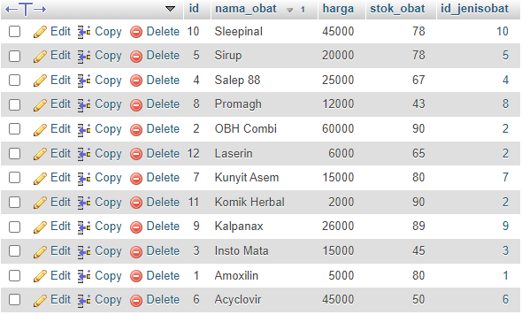

1. SELECT * FROM `obat` ORDER BY nama_obat ASC

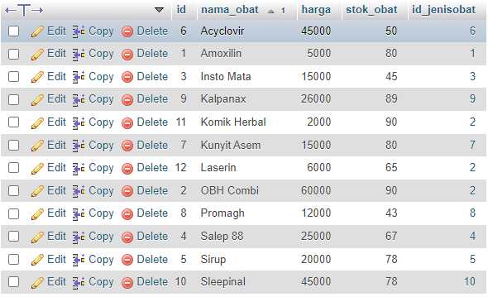

1. SELECT * FROM pelanggan WHERE jenis_kelamin LIKE '%Wanita%'

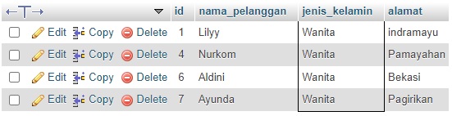

1. SELECT * FROM obat WHERE nama_obat LIKE 'S%'



1. SELECT nama_obat, SUM(stok_obat) AS total FROM `obat` GROUP BY nama_obat

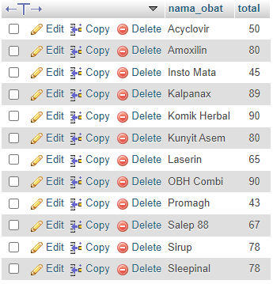

1. SELECT * FROM obat WHERE id_jenisobat = 2

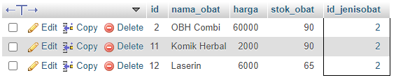

1. SELECT alamat FROM pelanggan GROUP BY alamat

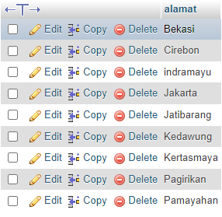

1. SELECT alamat, COUNT(id) FROM pelanggan GROUP BY alamat

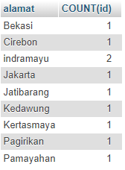

1. SELECT * FROM pelanggan LIMIT 5

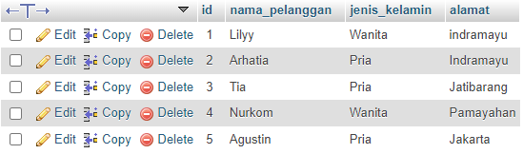

1. SELECT MIN(harga) FROM obat

